**Exercise No:2**

**Date:12/10/2020**

**Aim:**Given a list in Python and a number x, count number of occurrences of x in the given list.

Write a Python function **countX(lst, x)** to count the number x in a given list of numbers.

**Program:**

def countX(lst1,x1):

count=0

for i in range(0,len(lst1)):

if(x1==lst1[i]):

count=count+1

return count

lst=[]

n=int(input("No of elements"))

for i in range(0,n):

inp=int(input())

lst.append(inp)

print(lst)

x=int(input("The element to be searched"))

y=countX(lst,x)

print(y)

**Link:**

<http://103.53.53.18/mod/vpl/forms/edit.php?id=230&userid=1782>

**Output:**

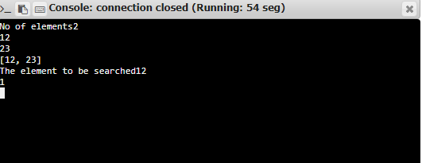

**Result:**

The program was executed successfully and the output was verified.